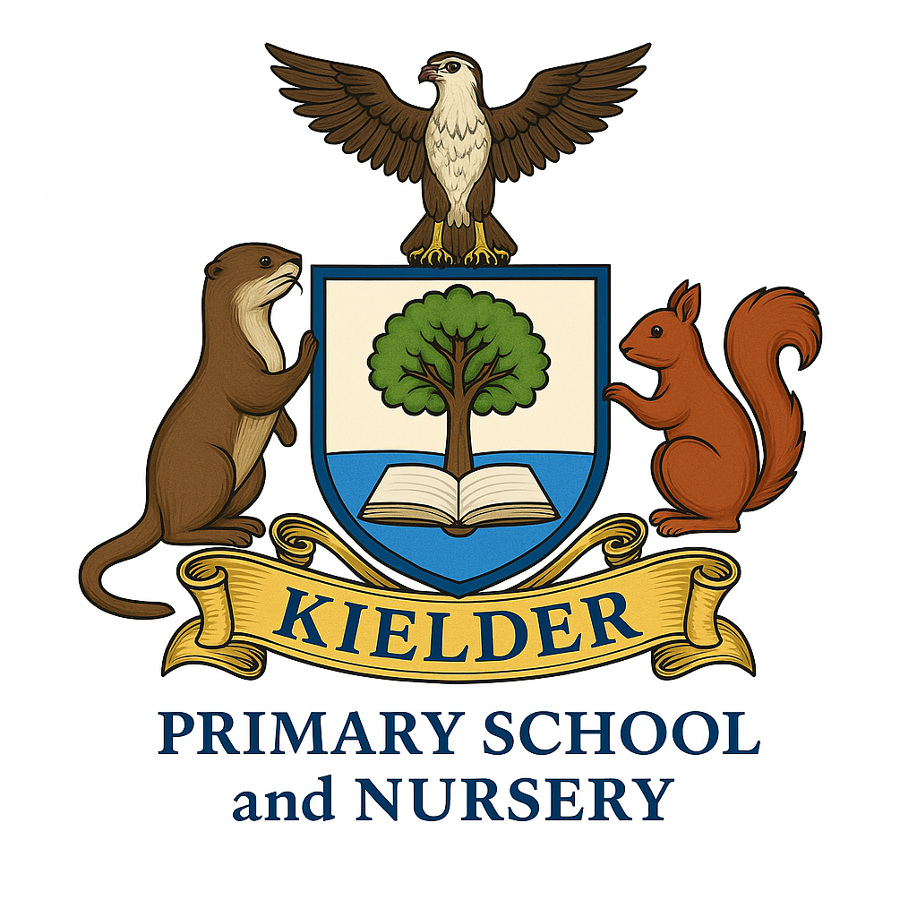

Published Equality Information and Objectives (2025-29)

POLICY STATUS

Date approved | September 2025
Review cycle | Every 4 years
Next review | September 2029
Approval level | Governing Body
The Public Sector Equality Duty (PSED) requires schools to consider how their policies and decisions impact people with protected characteristics. Schools must meet the following obligations to comply with the PSED:
- Consider equality implications: Consider equality implications before and during the process of developing policies and making decisions.
- Publish information: Publish information annually to demonstrate compliance with the PSED. Schools that employ 250 or more staff must also publish information on the gender pay gap of their employees.
- Publish objectives: Publish equality objectives at least once every four years.
- Eliminate discrimination: Have "due regard" to the need to eliminate discrimination, harassment, and victimisation.
- Advance equality of opportunity: Have "due regard" to the need to advance equality of opportunity between people who share a protected characteristic and those who don't.
- Foster good relations: Have "due regard" to the need to foster good relations between people who share a protected characteristic and those who don't.
- Monitor success: Monitor the success of any equality-related initiative.
- Record steps: Record all the steps taken to meet the duty.

About our school and our compliance with the duty

Our school is a very small primary school with a nursery in a very rural and remote part of England. We recognise the challenges we have in being able to embrace and treat fairly all of the protected characteristics and the diversity that makes up modern Britain, however we meet this challenge with enthusiasm, and embed awareness of diversity, fairness, equality and justice in the curriculum and the wider life of the school.
This information gives some examples of the ways in which we meet our duty.

Advance Equality of Opportunity
We teach children about their rights, and the school’s values, about respect for one-another and for people who may experience disadvantage, stigma or injustice in a local. national and global context. The children are aware of the orbits of learning that radiate around them, and of their place not only in society as they experience it in Kielder, but in regional, national and global contexts. As a school we form links with local schools (Greenhaugh, for example where we learn music together). Regionally, we are forming a link with a larger, more ethnically and culturally diverse school, Sacred Heart Primary School in Newcastle upon Tyne and a new partner school of a similar size in France in La Croisille-sur-Briance
We celebrate individuality and the unique talents and characteristics of each child. We promote and appreciate British values and celebrate traits such as respect, compassion and consideration for others and an appreciation of diverse viewpoints.
Every child in school has the option to joining either the Eco-Team or School Council and to experience campaigning, advocacy and democratic decision-making during their time with us.
We recognise that the cost-of-living crisis has affected families all over the country, and that rural hardship is sometimes less visible or can be overlooked when children live and are educated in an area with beautiful surroundings. Kielder is considered by many by many to be the most remote village in England. We support children who are eligible for Pupil Premium funding and others who experience periods of financial insecurity. We ensure that pupils have access to interventions and learning opportunities that diminish any disadvantage and to promote cultural capital; the essential knowledge and reference points that we all need as we move through life from school to social interactions and future job interviews.
To access enrichment such as sporting or cultural activities, children have to travel considerable distances from Kielder, so we try to ensure that we help all children to develop cultural capital as a matter of equality and social justice through a rich and vibrant programme of experiences during their time at school. After school enrichment activities take place on school premises for older children who arrive back in the village at the end of the school day. Sports facilitated by Newcastle United Foundation are timetabled for all of our pupils. We work closely with our closest family hub to ensure that families are supported and know how to access help with parenting, relationships, mental health, and financial difficulties as well as access to integrated services.

Eliminate discrimination
We promote gender equality and challenge gender stereotypes which is important in a very small school where it is quite possible to have fluctuating gender balance.
Our school uniform is flexible and affordable and the guidance does not have any rigid expectations that would be discriminatory due to reasons such as religion or belief, sex, disability, sensory needs or gender identity.
We consult with children and families when setting objectives for achievable and measurable objectives which will make the school more accessible for children with disabilities. They are outlined in more detail in the school’s accessibility plan.
We record and address any instances of discriminatory language, even when a child has been unaware of the impact of the language they have used. As a school we learn about fostering good relations and challenging discrimination in a practical context as children learn to navigate friendships, feelings and learning to speak to a trusted adult about concerns.
Staff and governors have competed training and have awareness of how to recognise a person vulnerable to radicalisation and to make a referral.
The school’s anti-bullying policy is on the web site, and we know from pupil voice activities that pupils feel safe and supported at Kielder primary.
Religious and faith-based respect and understanding is promoted by our school’s partnership with Tynedale Churches Partnership. The Community Cuppa events they organise are well attended by the local community and use the school as a base. In 2025, as part of this partnership, the school will be part of a unique project marking the 80th anniversary of the liberation of Auschwitz-Birkenau. For Holocaust Memorial Day (HMD) 2025, there will be a digital exhibition of 80 bespoke candleholders designed and created by communities and organisations from across the UK that highlight the life of an individual or a community persecuted by the Nazis. Our group has been recognising the life of an Italian Jewish boy . This will be a particularly poignant experience for our pupils to have their empathy and understanding of genocide and the Holocaust displayed and shared with a national audience.

Foster good relations
We have no children in Kielder who speak community languages other than English or who are from Global Majority heritage backgrounds. This presents challenges in representing and ensuring that children are prepared for contexts where the true cultural, ethnic and religious diversity of the wider UK are visible and routine. We achieve this through a well-planned curriculum which is taught to mixed age classes. We also welcome visitors and role models to our school and by ensuring that we plan a well-rounded and challenging programme of visits and learning opportunities, which can be achieved in our minibus due to the size of the school, for example to visit our school council partners in Newcastle.
When it is supplied as part of the admission process, we do record religion and belief and can be accordingly sensitive, respectful and inclusive towards diverse faiths and beliefs.
In accordance with the 2019 RSHE guidance we represent, discuss and welcome family diversity. We challenge any perception that family diversity is an uncomfortable or age-inappropriate concept for children; we are committed to discharging our legal duty to keep LGBT people safe from discrimination and representing the communities and contexts our children know and respect.

Published Objectives 2024-29:

Advance Equality of Opportunity: The Northumberland Inequalities Lens
People in the most deprived communities in Northumberland have shorter healthy lives than those in our least deprived.
A plan has been developed to reduce inequalities to enable people to live healthy, happy lives for longer.
One of the ways we are all working towards this is in ‘creating a system, including communities and residents in which everyone has responsibility for making change happen’. In Kielder, residents have limited access to many of the services, resources and facilities that are more readily available in other parts of the county, so knowing how to make the most of local, community-based assets becomes even more significant.

Our school plays its part as an essential community-based asset; we are the first point of contact for many of our families when challenges affect them, and we are a partner that they trust.

Our curriculum, visits and the experiences children have while they are pupils at Kielder Primary School set them up for life by developing the building blocks of social capital which children will need throughout their lives.

Cultural capital is the gathering of knowledge, behaviours, and skills that a child can draw upon and which demonstrates their cultural awareness, knowledge and competence; it is one of the key ingredients a child will draw upon to be successful in society, their career and the adult world.

What we will do
Continue to develop and extend the curriculum and the school-based enrichment experiences to prepare our children for their next steps at secondary or middle school, and for adult life.
Increase our knowledge and signposting for families experiencing periods of insecurity or hardship, so that children can thrive and our relationships with them and their families can flourish.
Develop and support flourishing partnerships such as those we have with community groups and Family Hubs.

Fostering good relations: Preparation for life in modern Britain
Children in our school community are respectful and kind, but we acknowledge that they do have fewer opportunities to experience life in modern Britain alongside multi-faith or linguistically and culturally diverse neighbours due to the rural context. Learning to enjoy and appreciate diversity and difference are consolidated by having opportunities to put the values into practice when we have partners and friends in contrasting locations, like Newcastle and France.
We recognise our responsibility to broaden children’s experiences of advocacy, protected characteristics, discussing inequality, the role of the bystander, how democracy affects us in a global, national and local context and safe and respectful relationships. We do this in age-appropriate ways through the curriculum and by offering opportunities for children to become engaged as representatives and advocates.

What we will do:
Continue to strengthen the School Council and Green Teams as opportunities for ever child in school to be able to participate in activities such as
- Auditing sustainability
- Campaigning for change
- Working with partners and support networks (climate change team, caretaker)
- Developing action plans
Work in partnership with the Schools Library Service to ensure that children have access to reading resources which represent and broaden their experiences of the world around them.

