

Marking, Feedback & Dialogue Policy

1. Introduction

“Feedback is one of the most powerful influences on learning and achievement.”
Hattie and Timperley, 2007

“Feedback should be provided to move learning forward.”
EEF, 2021

At Kielder Primary School, we recognise the importance of feedback and dialogue as part of the teaching and learning cycle and aim to maximise the effectiveness of its use. However, we are also mindful of the workload implications of written marking, and of the research surrounding effective feedback.

As the Department for Education’s research into teacher workload has highlighted written marking as a key contributing factor, we aim to find alternatives to onerous written marking which provide effective feedback in line with the EEF’s recommendations, and those of the DfE’s expert group which emphasises that marking should be meaningful, manageable and motivating.
We have also taken the advice provided by the NCETM (National Centre for Excellence in Teaching Mathematics) that the most important activity for teachers is the teaching itself, supported by the design and preparation of lessons.

2. Key Principles
We have taken as our central starting point the Education Endowment Foundation’s guidance report on teacher feedback to improve pupil learning.

This guidance makes six key recommendations:
- Lay the foundations for effective feedback
- Deliver appropriately timed feedback that focuses on moving learning forward
- Plan for how pupils will receive and use feedback
- Carefully consider how to use purposeful, and time-efficient, written feedback
- Carefully consider how to use purposeful verbal feedback
- Design a school feedback policy that prioritises and exemplifies the principles of effective feedback.

With this in mind, our policy on feedback has at its core a number of principles to ensure that it is both manageable and sustainable:
- Effective feedback is always underpinned by outstanding teaching.
- Written comments should only be used where they are accessible to students according to age and ability.
- Feedback is part of assessment processes in the classroom, and takes many forms other than written comments;
- Feedback is a part of the school’s wider assessment processes which aim to provide and appropriate level of challenge to pupils in lessons, allowing them to make good progress;
- All pupils’ work should be reviewed by teachers at the earliest appropriate opportunity so that it impacts on future learning. When work is reviewed, it should be acknowledged in books.
We believe that pupils’ self-esteem and resilience will develop through positive yet challenging feedback. As a result, this will accelerate progress. For this reason, all marking and feedback is underpinned by this policy, which all pupils and staff follow on a day-to-day basis.

3. Feedback and Marking in Practice
It is vital that teachers evaluate the work that children undertake in lessons and use the information obtained from this to adjust their teaching. Based on the work of the Assessment Commission, feedback will be given in three ways and aims to give teachers the ability to use the most effective forms of feedback:

- Immediate feedback – at the point of teaching, possibly 1:1 or in small groups
- Summary feedback – at the end of a lesson/task, possibly through a plenary
- Review feedback – away from the point of teaching (including written comments)
The stages are deliberately numbered in order of priority, noting that feedback closest to the point of teaching and learning is likely to be most effective in driving further improvement and learning.

Type | What it looks like | Evidence (for observers)
Immediate | - Includes teacher gathering and providing feedback from teaching (mini-whiteboards, book work etc).  - Takes place in lessons with individuals or small groups.  - Often given verbally to pupils for immediate action.  - Given by teacher and/or TA to provide support or further challenge.  - May redirect the focus of teaching or the task.  - May change the direction or teaching within the lesson.  - Effective questioning and mini-plenaries are key.  - Includes highlighting/annotations according to the marking code during the lesson | - Lesson observations/ learning walks  - Some evidence of annotations or use of marking code/ highlighting during work scrutiny  - Pupil voice illustrates children understand and can verbalise how and when marking is done.
Summary | - Often takes place at the end of a lesson or activity.  - Often involves whole groups or classes.  - Provides an opportunity for evaluation of learning in the lesson.  - May take the form of self or peer-assessment against an agreed set of criteria.  - May guide a teacher’s further use of review feedback, focusing on areas of need. | - Lesson observations/learning walks  - Evidence of self and peer-assessment  - May be reflected in selected focus review feedback (marking)
Review | - Takes place away from the point of teaching.  - May involve written comments/annotations for pupils to read/respond to.  - Provides teachers with opportunities for assessment of understanding.  - Leads to adaptation of future lessons through planning, grouping or adaptation of tasks.  - May lead to targets being set for pupils’ future attention or immediate action. | - Acknowledgement of work completed  - Written comments and appropriate responses/actions taken  - Adaptation to teaching sequences  - Use of annotations
At Kielder Primary School, this can be seen in the following practices:
3.1 Verbal feedback
At Kielder Primary School, we recognise the importance of regular, high-quality verbal feedback. Because we are fortunate enough to have very small classes, every child receives verbal feedback on their work, often multiple times in a lesson. Where verbal feedback requires action on the part of the pupil, staff will use a ‘Verbal feedback given’ stamp on the page. All pupils will tick the stamp to confirm that they have understood and acted on the feedback.
Verbal feedback can include praise but must also focus on how the pupil can produce the best possible work. Meaningful, high-quality verbal interactions are key in a small school. To that end, it is important that staff use careful language when issuing verbal feedback, avoiding ambiguity and vagueness.

Less effective verbal feedback ☹ | More effective verbal feedback 😊
“That’s great, well done.”  “You can do better than that – try harder.”  “You need to write more.” | “That’s great, well done. Could you go even further by …”  “Your work could be even better if you just add …”  “What do you think you could add to make your work even more impressive?”
3.2 Acknowledgment marking
The purpose of marking and feedback is to move learning on. However, we recognise that acknowledgement marking can have a positive impact on a child’s self-esteem and intrinsic motivation. Therefore, we respect our teachers’ professional judgement in terms of acknowledgement marking. Mindful of the need to minimise the time needed to mark work, teachers can decide when acknowledgement marking will be helpful to the pupil. It is important to emphasise that acknowledgement marking must not be done simply because the teacher feels a need to write ‘something’ on work. Acknowledgement marking may be through simple symbols such as ticks, stickers, stamps or ClassDojo points.

3.3 Assessment against the main enquiry question and ‘I can’ statements for the lesson
At Kielder Primary School, we use an enquiry question and ‘I can’ statements to introduce the objective and success criteria for the lesson. The enquiry question must be written in the pupils’ exercise books. KS2 pupils must write the question themselves, with the date. For younger pupils, the teacher/TA can either write the enquiry question into books or print it out and stick it in. As KS1 pupils grow in confidence with writing, they can begin to write in their own, along with the date. At the end of the lesson, following a plenary, pupils will indicate how confident they feel with answering the question using a method appropriate to the class. Teachers will also indicate whether they feel the pupil has achieved the objective for the lesson using a stamp.

3.4 Developmental marking
Detailed written comments will be focused on extended pieces of written work or extended tasks. At least one piece of extended writing per week must be marked developmentally in English. These will allow children’s achievements to be recognised and provide further guidance for future learning. Examples of this guidance could be:
- Reminder (most suitable for high achievers) - ‘What else could you say about …?’; ‘Explain your thinking about ….’; ‘Add more detail to ….’
- Scaffold (most suitable for children needing a little more support) - provide examples of what they need to do. Ask questions or provide unfinished sentences.
- Example prompt (suitable for all, especially lower abilities) - give children a choice of words or phrases e.g. “choose one of these words instead of bad.”
- Modelled example - a correct example modelled by a teacher/teaching assistant with a further one for the child to try.
- Open question - pose an open question specifically related to the objective to think about next steps.
- Greater depth/explanation - use to extend a child’s learning by asking them to explain their learning or reflect on the process or strategies they have used.
Stages of giving feedback
- Showing success (highlight in green - green is great, so children can see their successes clearly).
- Indicating improvement/next steps (draw a → as a visual symbol for ‘even better if’ or ‘next steps’). The class teacher marks in red pen and children respond in green, demonstrating further success through acting on feedback. See 3.4 Developmental marking for examples. This will happen in extended written pieces and 1-2 pieces of Maths work a week and in Science work, where appropriate.
- The child then responds to the teacher's comment.
- The teacher then reassesses (with a tick) the corrections/improvements to make sure they are complete.

Foundation subjects will be marked with a tick and ‘next steps’ criteria will be used if the teacher believes it is needed. High-frequency spelling errors will be addressed in foundation pieces of work and the children will respond to these by copying these words out three times at the start of the next lesson or ‘live’ in the lesson. Teachers/TAs should circulate to ensure words are being spelt correctly.

It is feasible in a school such as ours for teachers to give all pupils verbal feedback during a lesson. Self-assessment and peer-assessment should also be used where appropriate.
It is essential that time is given for children to respond to prompts, thus enabling them to ‘close the gap’ and improve their work. Dedicated time for making improvements needs to be planned. Children should use green pens and are expected to edit and improve their work or answer questions.
Teachers and teaching assistants should check that the improvement has been done through a simple tick. If misconceptions have occurred again, these will need to be addressed.
English
In-depth marking will take place after an independent writing piece using the marking codes (see appendices) to address basic skills and SPaG objectives. These pieces should be given more detailed written feedback. If a high-frequency word is misspelled, the teacher should identify this (up to 3 examples) and record the correct spelling on a Post-It note. Children should then write this spelling out three times. The teacher/TA MUST recheck this after the child has completed this to ensure these words are now spelt correctly. The Post-It note can then be re-used for continual review.

Maths
Indicating next steps in Maths 1-2 times a week enables pupils to reflect on mathematical concepts they may be struggling with. Giving pupils feedback as to how to overcome these barriers, including through worked examples, has the potential to be highly beneficial to pupils.

3.5 Children as markers (self and peer-assessment)
Self and peer-assessment have a key role to play in effective marking and feedback – they empower children to take control of their own learning. Teachers should employ these regularly within the teaching week.

Before any child (in Key Stage 1 and Key Stage 2) hands in any piece of work for marking they should spend an appropriate amount of time re-reading their work and making improvements. This time will be planned in as part of the self-assessment time either before the end of the lesson or as a focus of the next lesson, whichever is most appropriate for the task. A stamp will be used to indicate whether the work has been assessed by SELF, PEER or TEACHER.

3.6 Marking codes
Where written marking or annotations are appropriate, the intention is that minimum teacher time should lead to maximum outcomes. Teachers should complete a success criteria grid for extended written lessons. Marking codes have been developed for consistent use across the school to make feedback accessible for children and to make marking and feedback manageable for teachers although some additional age-appropriate elements may be included in some phases of the school, such as in Early Years.

Marking codes should be displayed in class, shared with children and stuck into books.

4. Roles and Responsibilities
- Teachers: Apply Marking, Feedback & Dialogue Policy consistently and contribute to policy review
- Headteacher: Oversees implementation and leads reviews
- Governors: Monitor impact of the policy

5. Policy monitoring, review and evaluation
Marking and feedback will be closely monitored by the Headteacher through:
- Lesson observations/learning walks
- Work reviews
- Pupil voice
- Moderation

POLICY STATUS

Approval date | July 2025
Review cycle | Every 2 years
Next review | July 2027
Approval level | Headteacher

Appendices
Appendix 1: Summary of marking requirements
Subject | Immediate | Summary | Review
English | Verbal feedback (teacher uses stamp, pupil ticks to indicate feedback has been acted upon).  Acknowledgement marking as appropriate. | Self and peer- assessment.  Traffic light plenaries. | Acknowledgement marking as appropriate.  High-frequency word written on a Post-It note for pupils to copy 3 times and re-use for continual review.  For extended writing (at least once per week):  - Success Criteria grid in books, completed by pupil/staff.  - Positives highlighted in green.  - Marking codes in margin to highlight errors.  - → indicates ‘even better if’ or next steps.  - Developmental feedback provided (see examples in Section 3.4).  - Pupils given time to act on feedback in green.
Maths |  | Self and peer- assessment.  Traffic light plenaries. | Acknowledgement marking as appropriate.  c used to highlight errors.  1-2 times per week: Developmental feedback given (see Section 3.4 for examples).
Science |  | Self and peer- assessment.  Traffic light plenaries. | Acknowledgement marking as appropriate.  High-frequency word written on a Post-It note for pupils to copy 3 times and re-use for continual review.  For extended writing:  - Positives highlighted in green.  - → indicates ‘even better if’ or next steps.  - Pupils given time to act on feedback in green.
Foundation subjects |  | Self and peer- assessment.  Traffic light plenaries. | - Work marked with a tick and ‘next steps’ (-->) criteria used if the teacher believes it is needed.  - 1-2 spelling errors will be addressed in foundation pieces of work and the children will respond to these by copying these words out three times.  - Teachers/TAs should circulate during the start of the lesson to ensure words are being spelt correctly.  - These spellings should be marked with a simple tick.
Appendix 2: Marking codes
- To be used in Key Stage 1 by ringing the mistake and placing the code above it.
- To be used in Key Stage 2 within the margin. Year 2 will transition to this in the Summer Term.
The coding must be available to children and staff in the classroom and exercise books to check regularly. Review marking should be completed neatly in red pen using the agreed school script.
Symbol | Meaning
P | Correct punctuation (sometimes accompanied by clue e.g . ! ? ‘ , : ; “ ).
CL | Capital Letter needed.
G | Correct the grammar.
SP. | Correct the spelling.
V | Improve vocabulary.
 | Add in the omitted word.
/ | Finger space is required.
\\ NP | Insert to show where a new paragraph should have been.
green highlighted bar | Impressive punctuation, vocabulary, conjunction, genre specific example.
E | Identifies a section that does not make sense or needs editing and improving.

Appendix 3: Success Criteria Tick Grid (KS1/2 - used for all pieces of extended writing)

Task | Supported work ⬜  Independent work ⬜  Verbal feedback given ⬜
Success Criteria | Self | Teacher

Appendix 4: Pictorial Success Criteria Grid (Reception/KS1 - used as appropriate)
 |  |  | 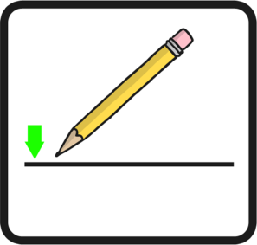
Capital Letters | Full stops | Correct letter orientation | Sit writing on the line
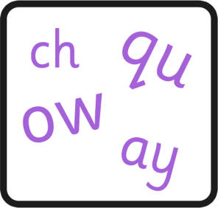 | 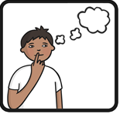 | 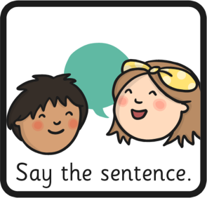 | 
Use phonics to spell | Think of a sentence | Say the sentence | Use finger spaces
 |  | 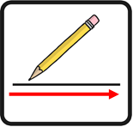 | 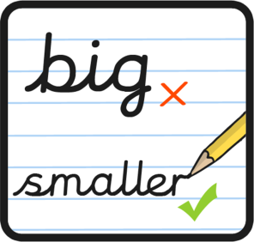
Use conjunctions | Spell HFW correctly | Write all the way along the line | Write smaller
 | 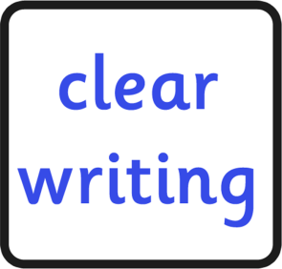 |  | 
Use exciting language | Write clearly | Question marks | Exclamation marks
 | 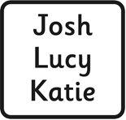 |  | 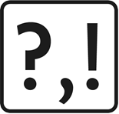
Use story language | Capital letters for proper nouns | Time conjunctions | Vary punctuation

Date:  Task: |  | Supported work ⬜  Independent work ⬜  Verbal feedback given ⬜
Success Criteria | Pupil | Teacher
