Marking, feedback and dialogue policy
Kielder Primary School & Nursery



POLICY STATUS

Date approved | September 2024
Review cycle | Every 2 years
Next review | September 2026
Approval level | Governing body, individual governor or headteacher

- Introduction

“Feedback is one of the most powerful influences on learning and achievement.”
Hattie and Timperley, 2007

“Feedback should be provided to move learning forward.”
EEF, 2021

At Kielder Primary School, we recognise the importance of feedback and dialogue as part of the teaching and learning cycle and aim to maximise the effectiveness of its use. However, we are also mindful of the workload implications of written marking, and of the research surrounding effective feedback.

As the Department for Education’s research into teacher workload has highlighted written marking as a key contributing factor, we aim to find alternatives to onerous written marking which provide effective feedback in line with the EEF’s recommendations, and those of the DfE’s expert group which emphasises that marking should be meaningful, manageable and motivating.
We have also taken the advice provided by the NCETM (National Centre for Excellence in Teaching Mathematics) that the most important activity for teachers is the teaching itself, supported by the design and preparation of lessons.

- Key principles
We have taken as our central starting point the Education Endowment Foundation’s guidance report on teacher feedback to improve pupil learning.

This guidance makes six key recommendations:
- Lay the foundations for effective feedback
- Deliver appropriately timed feedback that focuses on moving learning forward
- Plan for how pupils will receive and use feedback
- Carefully consider how to use purposeful, and time-efficient, written feedback
- Carefully consider how to use purposeful verbal feedback
- Design a school feedback policy that prioritises and exemplifies the principles of effective feedback.

With this in mind, our policy on feedback has at its core a number of principles to ensure that it is both manageable and sustainable:
- Effective feedback is always underpinned by outstanding teaching.
- Written comments should only be used where they are accessible to students according to age and ability.
- Feedback is part of assessment processes in the classroom, and takes many forms other than written comments;
- Feedback is a part of the school’s wider assessment processes which aim to provide and appropriate level of challenge to pupils in lessons, allowing them to make good progress;
- All pupils’ work should be reviewed by teachers at the earliest appropriate opportunity so that it impacts on future learning. When work is reviewed, it should be acknowledged in books.
We believe that pupils’ self-esteem and resilience will develop through positive yet challenging feedback. As a result, this will accelerate progress. For this reason, all marking and feedback is underpinned by this policy, which all pupils and staff follow on a day-to-day basis.
- Feedback and marking in practice
It is vital that teachers evaluate the work that children undertake in lessons and use the information obtained from this to adjust their teaching. Based on the work of the Assessment Commission, feedback will be given in three ways and aims to give teachers the ability to use the most effective forms of feedback:

- Immediate feedback – at the point of teaching, possibly 1:1 or in small groups
- Summary feedback – at the end of a lesson/task, possibly through a plenary
- Review feedback – away from the point of teaching (including written comments)
The stages are deliberately numbered in order of priority, noting that feedback closest to the point of teaching and learning is likely to be most effective in driving further improvement and learning.
At Kielder Primary School, this can be seen in the following practices:
Type | What it looks like | Evidence (for observers)
Immediate | - Includes teacher gathering and providing feedback from teaching (mini-whiteboards, book work etc).  - Takes place in lessons with individuals or small groups.  - Often given verbally to pupils for immediate action.  - Given by teacher and/or TA to provide support or further challenge.  - May re-direct the focus of teaching or the task.  - May change the direction or teaching within the lesson.  - Effective questioning and mini-plenaries are key.  - Includes highlighting/annotations according to the marking code during the lesson | - Lesson observations/ learning walks  - Some evidence of annotations or use of marking code/ highlighting during work scrutiny  - Pupil voice illustrates children understand and can verbalise how and when marking is done.
Summary | - Often takes place at the end of a lesson or activity.  - Often involves whole groups or classes.  - Provides an opportunity for evaluation of learning in the lesson.  - May take the form of self or peer-assessment against an agreed set of criteria.  - May guide a teacher’s further use of review feedback, focusing on areas of need. | - Lesson observations/learning walks  - Evidence of self and peer-assessment  - May be reflected in selected focus review feedback (marking)
Review | - Takes place away from the point of teaching.  - May involve written comments/annotations for pupils to read/respond to.  - Provides teachers with opportunities for assessment of understanding.  - Leads to adaptation of future lessons through planning, grouping or adaptation of tasks.  - May lead to targets being set for pupils’ future attention or immediate action. | - Acknowledgement of work completed  - Written comments and appropriate responses/actions taken  - Adaptation to teaching sequences  - Use of annotations

3.1 Verbal feedback
At Kielder Primary School, we recognise the importance of regular, high-quality verbal feedback. Because we are fortunate enough to have very small classes, every child receives verbal feedback on their work. Where verbal feedback requires action on the part of the pupil, staff will use a ‘Verbal feedback given’ stamp in the margin. All pupils will tick the stamp to confirm that they have understood and acted on the feedback. Pupils in UKS2 will also write what they have done in the margin.

Verbal feedback can include praise but must also focus on how the pupil can produce the best possible work. Meaningful, high-quality verbal interactions are key in a small school. To that end, it is important that staff use careful language when issuing verbal feedback, avoiding ambiguity and vagueness.

Less effective verbal feedback ☹ | More effective verbal feedback 😊
“That’s great, well done.”  “You can do better than that – try harder.”  “You need to write more.” | “That’s great, well done. Could you go even further by …”  “Your work could be even better if you just add …”  “What do you think you could add to make your work even more impressive.”

3.2 Acknowledgment marking
The purpose of marking and feedback is to move learning on. However, we recognise that acknowledgement marking can have a positive impact on a child’s self-esteem and intrinsic motivation. Therefore, we respect our teachers’ professional judgement in terms of acknowledgement marking. Mindful of the need to minimise the time needed to mark work, teachers can decide when acknowledgement marking will be helpful to the pupil. It is important to emphasise that acknowledgement marking must not be done simply because the teacher feels a need to write ‘something’ on work. Acknowledgement marking may be through simple symbols such as ticks, stickers, stamps or ClassDojo points.

3.3 Assessment against the learning objective (WALT)
At Kielder Primary School, we use ‘We Are Learning To’ (WALT) statements to introduce the objective for the lesson. This method of objective setting puts the focus on key learning verbs (e.g. ‘identify’, ‘classify’, ‘analyse’). The WALT must be written in the pupils’ exercise books. For younger pupils, the teacher/TA will either write the WALT into books or print it out and stick it in. Older pupils will write their own WALTs into their books. At the end of the lesson, following a plenary, pupils will indicate how confident they feel with the WALT using a method appropriate to the class. Teachers will also indicate whether they feel the pupil has achieved the WALT for the lesson using a stamp.

3.4 Developmental marking
Detailed written comments will be focused on extended pieces of written work or extended tasks. At least one piece of extended writing per week must be marked developmentally (in English or a foundation subject if appropriate). These will allow children’s achievements to be recognised and provide further guidance for future learning. Examples of this guidance could be:
- Reminder (most suitable for high achievers) - ‘What else could you say about …?’; ‘Explain your thinking about ….’; ‘Add more detail to ….’
- Scaffold (most suitable for children needing a little more support) - provide examples of what they need to do. Ask questions or provide unfinished sentences.
- Example prompt (suitable for all, especially lower abilities) - give children a choice of words or phrases e.g. “choose one of these words instead of bad.”
- Modelled example - a correct example modelled by a teacher/teaching assistant with a further one for the child to try.
- Open question - pose an open question specifically related to the WALT to think about next steps.
- Greater depth/explanation - use to extend a child’s learning by asking them to explain their learning or reflect on the process or strategies they have used.
Stages of giving feedback
- Showing success (highlight in green - green is great, so children can see their successes clearly).
- Indicating improvement/next steps (draw a → as a visual symbol for ‘even better if’). The class teacher marks in red pen and children respond in green, demonstrating further success through acting on feedback. See 3.4 Developmental marking for examples. This will happen in all extended written pieces, two Maths pieces of work a week and in Science.
- A page Post-It is placed on the page where the teacher comment is to signpost children to where a response to feedback is required.
- The child then responds to the teacher comment.
- The page Post-It is kept on the piece of work until the teacher collects the books at the end of the lesson.
- The teacher then reassesses (with a tick) the corrections to make sure they are complete and then removes the page Post-It.

*Foundation subjects will be marked with a tick and ‘next steps’ criteria will be used if the teacher believes it is needed. 1-2 spelling errors will be addressed in foundation pieces of work and the children will respond to these by copying these words out three times at the start of the next lesson. Teachers/TAs should circulate during the start of the lesson to ensure words are being spelt correctly. These spellings should be marked with a simple tick and checked at the next point of marking/assessment.

It is feasible in a school such as ours for teachers to give all pupils verbal feedback during a lesson. Self-assessment and peer-assessment should also be used where appropriate.
It is essential that time is given for children to respond to prompts, thus enabling them to ‘close the gap’ and improve their work. Dedicated time for making improvements needs to be planned. Children should use green pens and are expected to edit and improve their work or answer questions.
Teachers and teaching assistants should check that the improvement has been done through a simple tick. If misconceptions have occurred again, these will need to be addressed.
Specific examples - Maths
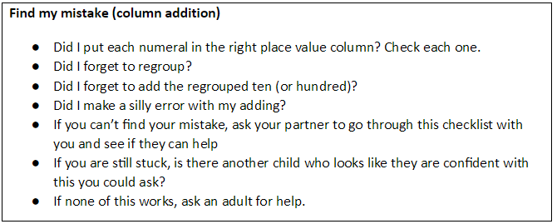
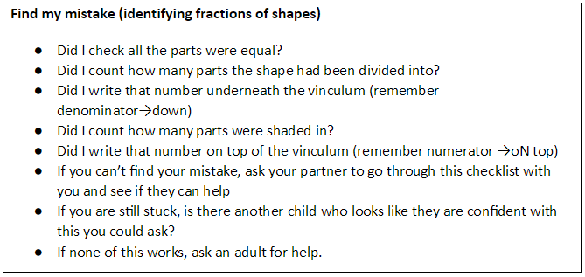

Specific examples - English
In-depth marking will take place after an independent writing piece using the marking codes (see appendices) to address basic skills and SPaG objectives. These pieces should be given more detailed written feedback.

If a high-frequency word is misspelt, the teacher should identify this (up to 3 examples) and record the correct spelling at the end of a piece of work. Children should then write this spelling out three times. The teacher/TA MUST recheck this after the child has completed this to ensure these words are now spelt correctly.

‘Going for Gold’
‘Going for Gold’ marking is used for extended writing. All pupils should know what they can do to take their work to the ‘next level’. Because of the nature of extended writing, it is unlikely that most pupils will have no improvements to make. However, because pupils’ attention will already have been drawn to their functional errors by means of coding (see above), GfG marking must enable the pupils to include an additional element in order to push themselves even further. For pupils who have met the WALT for the lesson, this will mean making reference to either a previously taught element that they pupils could have spontaneously included (retrieval) or to the next phase of learning to be covered. By the time this next phase has been completed and another extended piece of writing completed, the pupils will be able to ‘go for gold’.

3.5 Children as markers (self and peer-assessment)
Self and peer-assessment have a key role to play in effective marking and feedback – they empower children to take control of their own learning. Teachers should employ these regularly within the teaching week.

Before any child (in Key Stage 1 and Key Stage 2) hands in any piece of work for marking they should spend an appropriate amount of time checking they re-read their work and made improvements. This time will be planned in as part of the self-assessment time either before the end of the lesson or as a focus of the next lesson, whichever is most appropriate for the task. A stamp will be used to indicated whether the work has been assessed by SELF, PEER or TEACHER.

3.6 Marking codes
Where written marking or annotations are appropriate, the intention is that minimum teacher time should lead to maximum outcomes. Teachers should complete a success criteria grid for extended written lessons and Science (see appendix). Marking codes have been developed for consistent use across the school to make feedback accessible for children and to make marking and feedback manageable for teachers although some additional age-appropriate elements may be included in some phases of the school, such as in Early Years.

Marking codes should be displayed in class, shared with children and stuck into books.
3.7 Policy monitoring, review and evaluation
Marking and feedback will be closely monitored by subject leaders and the Headteacher through:
- Lesson observations/learning walks
- Book scrutiny
- Pupil discussion
- Moderation

Appendices
Appendix 1: Summary of marking requirements
Subject | Immediate | Summary | Review
English | Verbal feedback (teacher uses stamp, pupil ticks to indicate feedback has been acted upon).  Acknowledgement marking as appropriate. | Self and peer- assessment.  Traffic light plenaries. | Acknowledgement marking as appropriate.  High-frequency word misspellings highlighted and copied three times.  For extended writing:  - Success Criteria grid in books, completed by pupil/staff.  - Positives highlighted in green.  - Marking codes in margin to highlight errors.  - → indicates ‘even better if’.  - Page Post-It signposts to review work needed.  - Pupils given time to act on feedback.  - ‘Going for Gold’ feedback given as appropriate.
Maths |  | Self and peer- assessment.  Traffic light plenaries. | Acknowledgement marking as appropriate.  High-frequency mathematical word misspellings highlighted and copied three times.  c in margin used to highlight errors.  2 x per week: Developmental feedback given (see Section 3.4 for examples).
Science |  | Self and peer- assessment.  Traffic light plenaries. | Acknowledgement marking as appropriate.  High-frequency word misspellings highlighted and copied three times.  For extended writing:  - Success Criteria grid in books, completed by pupil/staff.  - Positives highlighted in green.  - Marking codes in margin to highlight errors.  - → indicates ‘even better if’.  - Page Post-It signposts to review work needed.  - Pupils given time to act on feedback.  - ‘Going for Gold’ feedback given as appropriate.
Foundation subjects |  | Self and peer- assessment.  Traffic light plenaries. | - Work marked with a tick and ‘next steps’ (🡪) criteria used if the teacher believes it is needed.  - 1-2 spelling errors will be addressed in foundation pieces of work and the children will respond to these by copying these words out three times at the start of the next lesson.  - Teachers/TAs should circulate during the start of the lesson to ensure words are being spelt correctly.  - These spellings should be marked with a simple tick and checked at the next point of marking/assessment.

Appendix 2: Marking codes
- To be used in Key Stage 1 by ringing the mistake and placing the code above it.
- To be used in Key Stage 2 within the margin. Year 2 will transition to this in the Summer Term.
The coding must be available to children and staff in the classroom and exercise books to check regularly. Review marking should be completed neatly in red pen using the agreed school script.
Margin  Symbol | Meaning
P | Correct punctuation (sometimes accompanied by clue e.g . ! ? ‘ , : ; “ ).
CL | Capital Letter needed.
G | Correct the grammar.
SP. | Correct the spelling.
V | Improve the vocabulary.
 | Add in the omitted word.
/ | Finger space is required.
\\ NP | Insert to show where a new paragraph should have been.
c | Correction is needed (specifically used in Maths). This is to be revisited and marked by the adult when visited during next marking session.
green highlighted bar | Impressive punctuation, vocabulary, conjunction, genre specific example.
E | Identifies section that does not make sense or needs editing and improving.

Appendix 3: Success Criteria Tick Grid (KS1/2 - used for all pieces of extended writing)
Link to NC |   Supported work   Independent work   Verbal feedback given 
Success Criteria | Self | Teacher

Appendix 4: Pictorial Success Criteria Grid (Reception/KS1 - used as appropriate)
 |  | 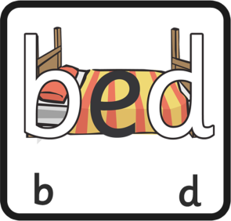 | 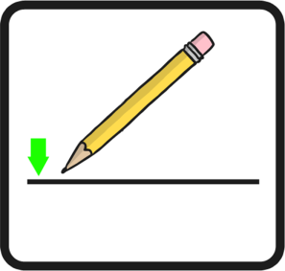
Capital Letters | Full stops | Correct letter orientation | Sit writing on the line
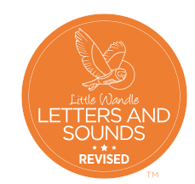  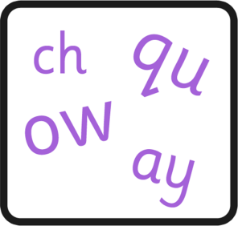 | 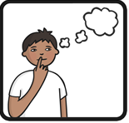 | 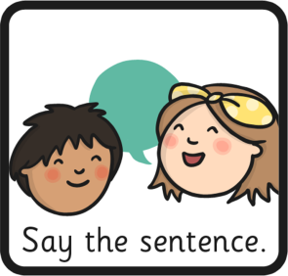 | 
Use phonics to spell | Think of a sentence | Say the sentence | Use finger spaces
 |  | 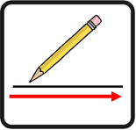 | 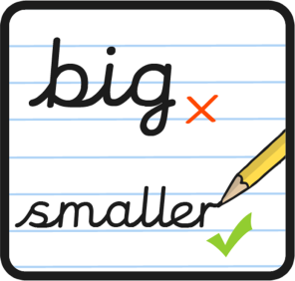
Use conjunctions | Spell HFW correctly | Write all the way along the line | Write smaller
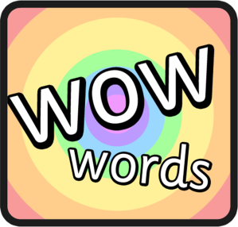 | 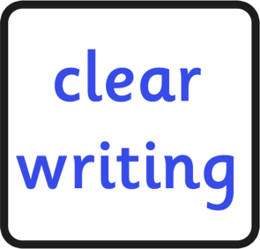 |  | 
Use exciting language | Write clearly | Question marks | Exclamation marks
 | 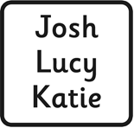 |  | 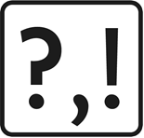
Use story language | Capital letters for proper nouns | Time conjunctions | Vary punctuation

Thursday 18th March 2021  WALT: Write sentences to retell a story |  | Supported work   Independent work   Verbal feedback given 
Success Criteria | Pupil | Teacher
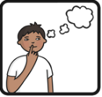
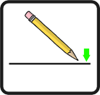
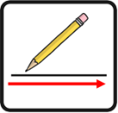


Appendix 5: EEF feedback guidance
